**Chapter 2 Notes**

**I. The Law of Conservation of Mass-** In a chemical reaction, matter is neither created nor destroyed.

**II. The Law of Definite Proportions-** All samples of a given compound, regardless of their source or how they were prepared, have the same proportions of their elements.

**III. The Law of Multiple Proportions-** When two elements (call them A and B) form different compounds ( like AB and AB2), the masses of element B that combine with element A can be expressed as a ratio of small whole numbers.

**IV. Atomic Theory**

*A. John Dalton* (1808)

1. Each element is composed of tiny, indestructible particles called atoms.

2. All atoms of a given element have the same mass and other properties that distinguished them from the atoms of other elements.

3. Atoms combine in simple, whole-number ratios to form compounds.

4. Atoms of one element cannot change into atoms of another element.

B*. JJ Thomson* (late 1800’s)

1. Used a cathode ray to discover the electron.

C. *Robert Millikan* (1909)

1. Oil Drop Experiment discovered the charge of an electron which is -1.60 X 10-19Coulombs.

2. Was able to determine mass of electron using mass to charge ratio

D. *Rutherford* (1909)

1. Used gold foil experiment to determine that most of atoms mass and all of its positive charge are contained in the nucleus.

2. Most of the volume of the atom is empty space, throughout which tiny, negatively charged electrons are dispersed.

3. There are as many negatively charged electrons outside the nucleus as there are positively charged particles(protons) within the nucleus, so the atom is electrically neutral.

E. *Chadwick*

1. Discovered the neutron.

**V. Atoms**- smallest part of an element that retains the chemical properties of that element.

|  |  |  |  |
| --- | --- | --- | --- |
| **Particle** | **Charge** | **Mass (amu)** |  |
| **Proton** | **Positive** | **1.0073** | **Determines atomic number; gives element its identity** |
| **Neutron** | **No charge** | **1.0087** | **Determines mass number;** |
| **Electron** | **Negative** | **5.486 X 10-4** | **Responsible for bonding** |

**VI. Isotopes and Isotope Notation**

**Isotope – atoms of the same element (therefore they have the same number of protons), but have different number of neutrons (therefore the mass number is different.**

**Isotope Notation**



mass numberA element symbol atomic numberZ

**atomic number(Z)**--The number of p+ in an atom. All atoms of the *same* element have the *same number* of p+.

**mass number(A)**--The sum of the number of neutrons and p+ for an atom. A different mass number *does not* mean a different element--just an isotope

|  |  |  |  |  |
| --- | --- | --- | --- | --- |
| **Isotope** | **Number of Protons** | **Number of Neutrons** | **Atomic Number** | **Mass Number** |
|  | **6** | **6** | **6** | **12** |
|  | **6** | **8** | **6** | **14** |

**Average Atomic mass -** weighted average mass of the isotopes of that element. This is the decimal number on the periodic table.

**a. average atomic mass = (Percent X Mass Number)isotope 1 + (Percent X Mass Number)isotope 2…**

***A. Chlorine***

***25% is chlorine-37***

***75% is chlorine – 35***

***What is the average atomic mass of chlorine?***

**Percent Abundance--**

**a. percent abundance = number of atoms of a given isotope x 100 Total number of atoms of all isotopes of that element**

**VII. Ions-** A neutral atom (same number of protons and electrons) gains or loses electrons to become charged particles called ions.

A. Cation- an atom that loses electrons to become pawsitively charged.

Li 🡪 Li+ + e-

B. Anion – an atom that gains electrons to become negatively charged.

F + e- 🡪 F-

Oxidation Number +1 +2 +3 +/-4 -3 -2 -1 0

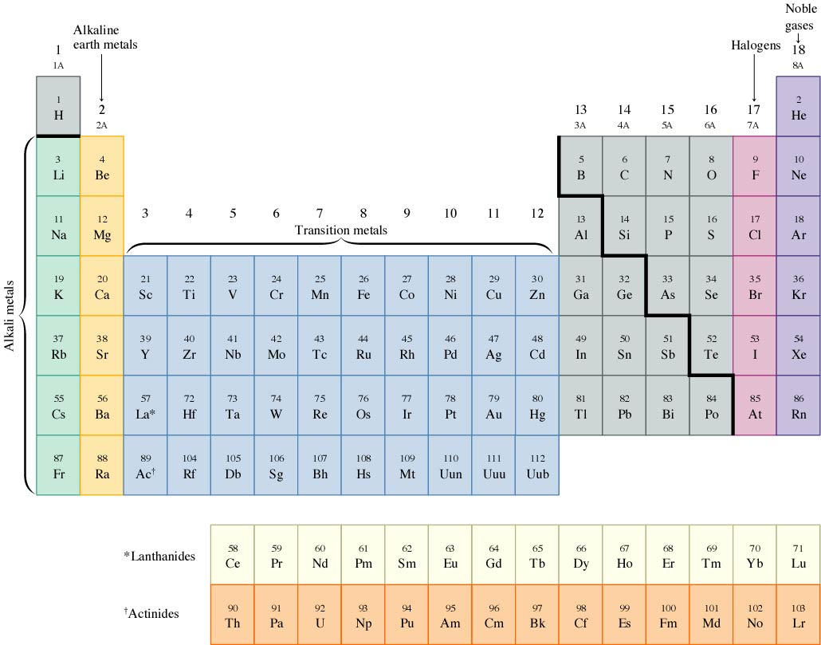**Oxidation Number**- the number of electrons that are lost or gained from an atom during bonding.

Oxidation Number- the number of electrons lost or gained during bonding.

**groups or families**--vertical columns; have similar physical and chemical properties.

**group A**—Representative elements

**group B**--transition elements; all metals; have numerous oxidation/valence states

**periods**--horizonal rows; progress from metals to metalloids [either side of the black “stair step” line that separates metals from nonmetals] to nonmetals

*Group 1* – Alkali Metals *Group 2*- Alkali Earth Metals *Group 17*- Halogens *Group 18* –Noble Gases

**VIII. Mole**

**1 mole = 6.02 X 1023 particles, molecules, electrons**

**1 mole = 22.4 liters of gas at STP**

**1 mole = molar mass in grams**

Remember the mole map

Liters of gas

@ STP

# particles

6.02 x 1023 22.4 L

# of Moles

Molar Mass (MM)

Mass in grams

1. **Molar Mass**- is the mass (think grams) of one mole of a substance

a. Atomic masses of atoms are relative masses based on the mass of carbon-12

b. To calculate the molar mass of a compound, you add up the molar masses of all the elements

in that compound.

**IX. Mass spectrometry- a device for measuring the mass of atoms or molecules**

In order to measure the characteristics of individual molecules, a mass spectrometer converts them to ions so that they can be moved about and manipulated by external electric and magnetic fields. The three essential functions of a mass spectrometer, and the associated components, are:

**1.**   A small sample is ionized, usually to cations by loss of an electron.   **The Ion Source**  
**2.**   The ions are sorted and separated according to their mass and charge.   **The Mass Analyzer**  
**3.**   The separated ions are then measured, and the results displayed on a chart.   **The Detector**

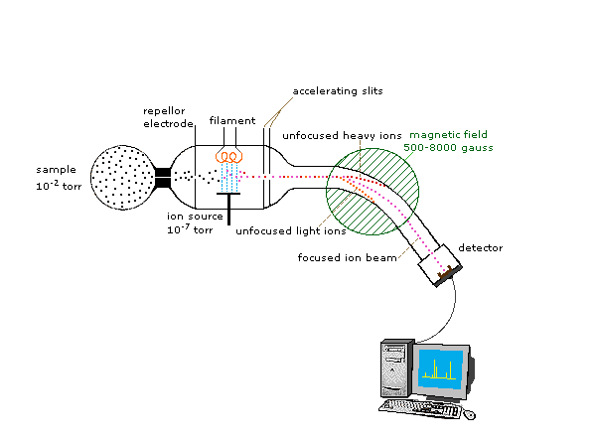

The ability of a mass spectrometer to distinguish different isotopes is one of the reasons why mass spectrometry is such a powerful technique. The presence of isotopes – a presence that is ubiquitous in nature – gives each fragment a characteristic series of peaks with different intensities. These intensities can be predicted based on the abundance of each isotope in nature, and the relative peak heights can also be used to assist in the deduction of the empirical formula of the molecule being analyzed.

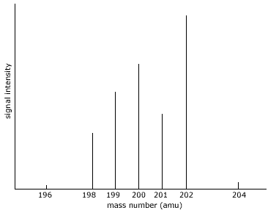

From this we can identify seven isotopes of mercury with mass numbers (A):

196, 198, 199, 200, 201, 202, and 204.

Because the height of each peak is proportional to the number of ions of each mass, the relative heights of each peak correspond to the percentage abundance of each isotope.

This data is often presented in a table:

|  |  |  |
| --- | --- | --- |
| **Mass Number (A)** | **Isotopic Mass (amu)** | **% Abundance** |
| 196 | 195.165 | 0.14 |
| 198 | 197.967 | 10.04 |
| 199 | 198.967 | 16.83 |
| 200 | 199.968 | 23.12 |
| 201 | 200.970 | 13.23 |
| 202 | 201.970 | 29.79 |
| 204 | 203.973 | 6.85 |

This data can be used to calculate the relative atomic mass (r.a.m.) of the element